Name: Parth Sandip Sante

Roll no. A055

Step 1: Go to AWS search bar and look for S3

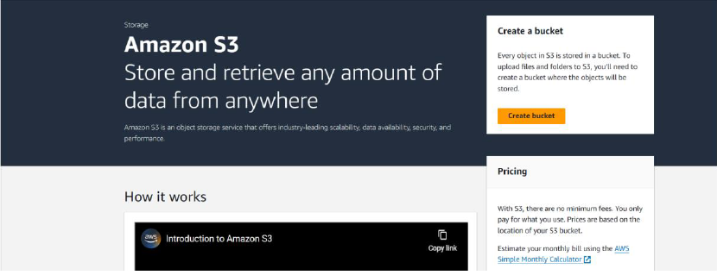

Step 2: Create a bucket with a name. I named it “bucketpractical1”.

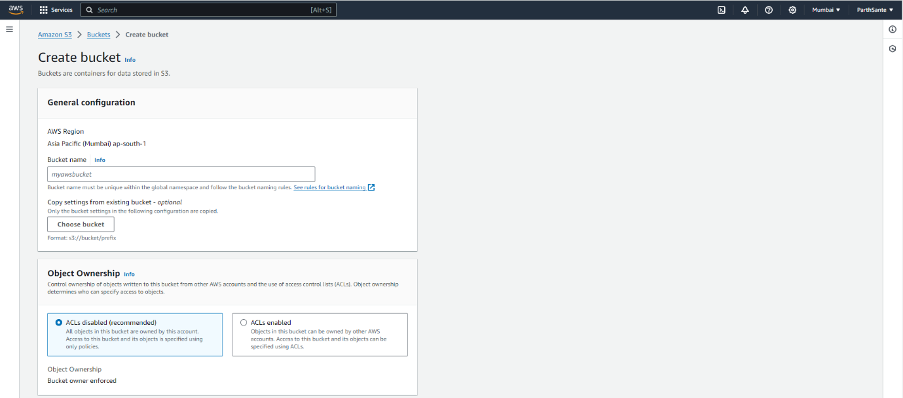

Step 3: Block the public access and disable Bucket key.

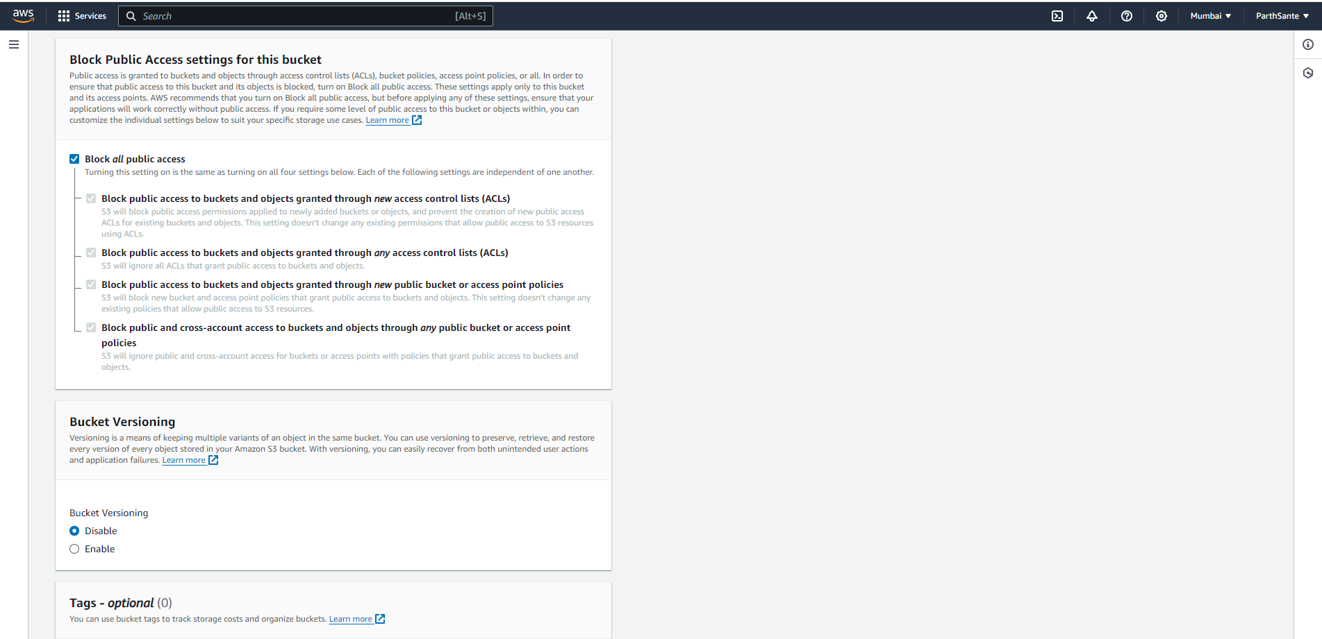

Step 4: Click on “Create Bucket” to create the bucket.

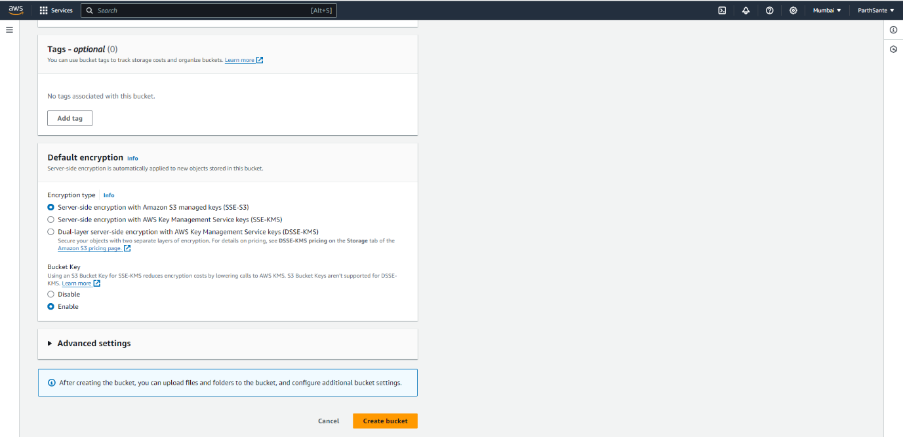

Here, you can see that the bucket named “bucketpractical1” has been created.

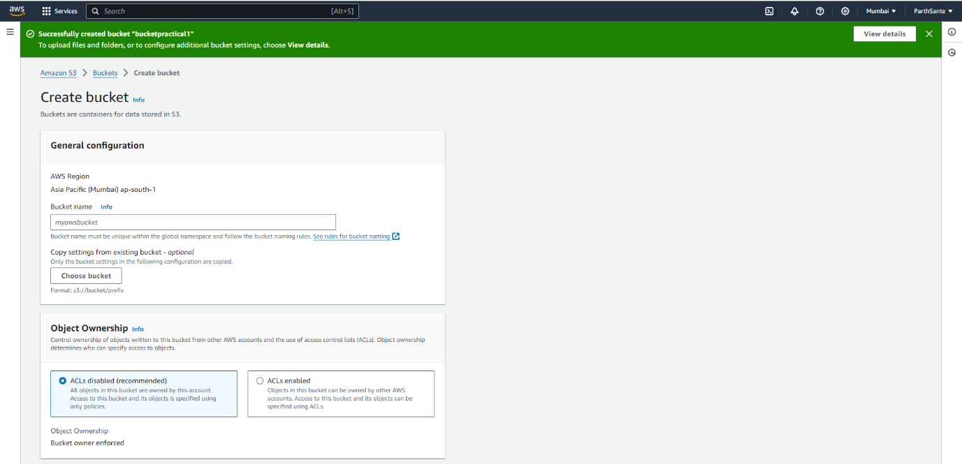

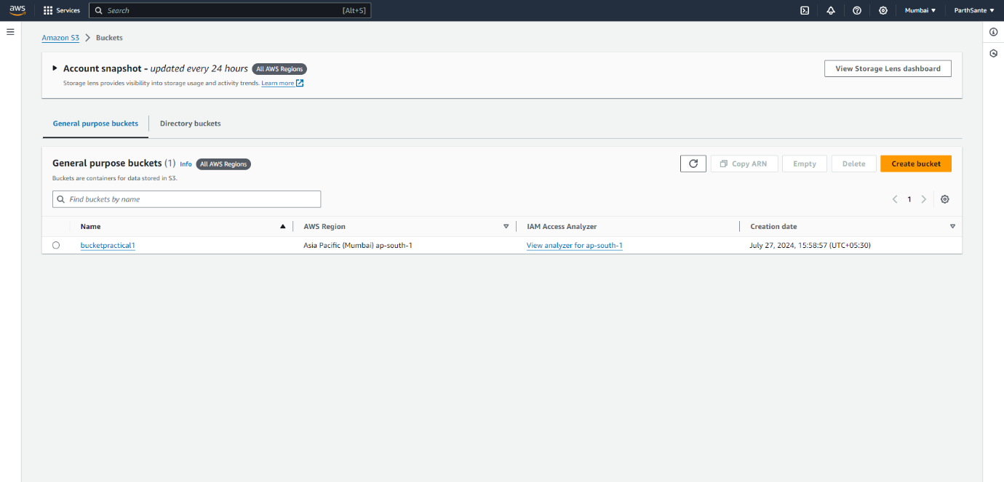

Step 5: Here, I have created 2 folders in this bucket. One to upload an image and one for a HTML website.

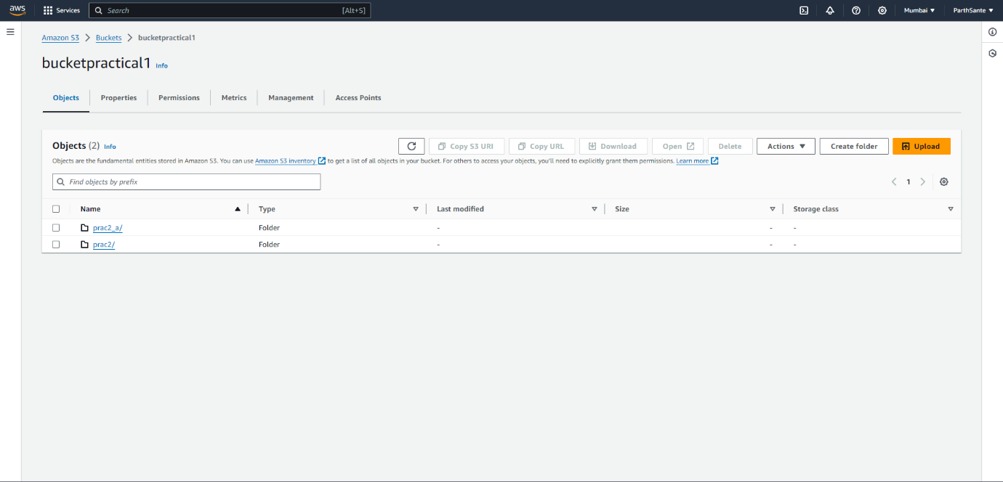

Step 6: An Image is uploaded in the “prac2” folder.

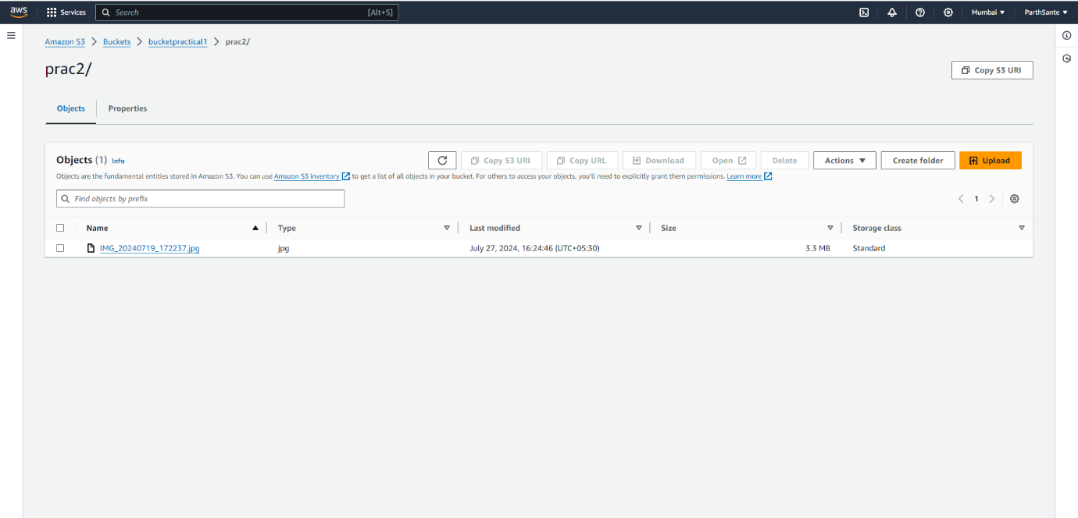

Here is the preview of the image.



Step 7: In another folder, a HTML website has been uploaded.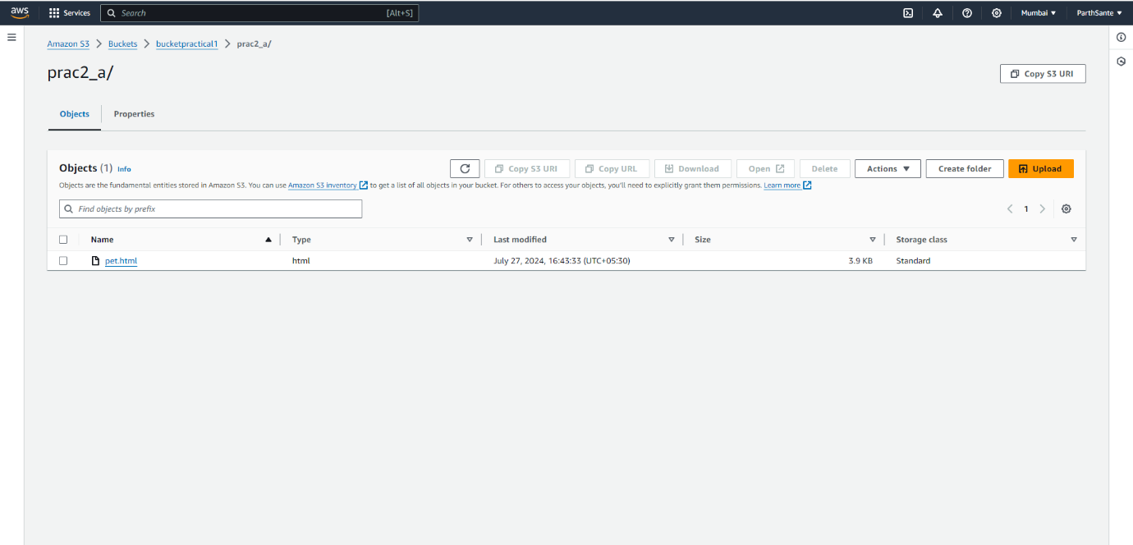

Here is the preview of the HTML website.

